**Master Indices for initializing spatial, seasonal, mULti-Fleet, multi-stock models: Alternative indices and sensitivities**

Tom Carruthers[1]

*SUMMARY*

Version 5 of the M3 model is presented that now calculates apical fishing mortality rates based on annual deviations from a spatial-seasonal index of abundance – the master index. Multiple indices and index weightings are proposed to test whether the model estimates of M3 version 5 are dependent on the choice of master index, a model input that has not yet been subject to detailed peer review. Three master indices of varying seasonal-spatial distribution and trend were constructed from varying data sources. When the influence of these indices was down-weighted by prescribing a large coefficient of variation in the annual deviations, M3 model predictions were similar, independent of the master index used.

*KEYWORDS*

*Abundance indices, Spatial modelling, Operating model, sensitivity analysis, bluefin tuna, stock assessment*

# Introduction

The Atlantic Bluefin tuna Management Strategy Evaluation process is based on a spatial, seasonal, multi-fleet, multi-stock operating model known as M3 (Carruthers et al. 2015a, SCRS/2015/179). The model incorporates a wide range of fishery dependent and independent data (e.g. spatial CPUE indices, spawning surveys, acoustic surveys, electronic tagging and genetics data) to estimate the seasonal, spatial distribution of the combined stock over time (Carruthers et al. 2015b, SCRS/2015/180).

To varying degrees parameters may be confounded in conventional spatially aggregated, annual stock assessment models. For example, the unfished stock size (often parameterized as unfished recruitment, *R0*) is often negatively related to estimates of fishing mortality rate. Parameter confounding inhibits numerical convergence on a global optima and can require a very large number of MCMC samples to satisfy convergence diagnostics.

Problems of model identifiability are significantly increased in multi-stock fisheries models where, as in the example above, the unfished stock size of the multiple populations are confounded with each other and fishing mortality rates. Similarly, spatial models can explain spatial distribution according to a much larger set of movement scenarios. It follows that for complex models such as M3, the global objective function is complex with respect to the various estimated parameters for which there are likely to be many local optima. In such a poorly defined optimization problem, numerical optimization procedures may either fail to converge on a solution or take a prohibitive amount of time to converge on a solution.

The M3 model uses three tactics to address this problem: initialization of estimation at numerically stable values, priors and relaxation. The model initializes at a guess at temporal, spatial and seasonal abundance distribution and trend, assumes a prior for this distribution the strength of which is relaxed (made less informative) over successive phases of the numerical optimization.

Initial information of spatial, seasonal population abundance is achieved through a single index, referred to as the ‘master index’. The model uses the master index *I* to derive standardized fishing effort *E* by dividing fishery catches *C* by the master index *I*:

*Ey,s,a,f = Cy,s,a,f* / *Iy,s,a* (1)

This means that the model can predict fishing mortality rate *F*,and hence catches by simply estimating a single catchability parameter *q*, per fleet (as opposed to a fishing mortality rate per year *y*, season *s*, area *a*, and fleet *f*:

*Fy,s,a,f = qf ∙ Ey,s,a,f*  (2)

Since the current version of M3 (4.5.1) includes 52 historical years, 4 seasons, 7 areas and 15 fleets there are as many as 21,840 fishing mortality rate parameters. Equations 1 and 2 reduce estimation requirements from this very large number to just 15, one *q* per fleet. The limitation of this approach is that both trend and absolute level of seasonal - spatial abundance is essentially predetermined (hard-wired) by the master index. Any deviations that occur must happen at the cost of mis-fit to the observed catches.

To allow for seasonal deviations in magnitude of abundance a spatial-seasonal deviation *θ* can be added:

*Fy,s,a,f = qf ∙ Ey,s,a,f  ∙* exp(*θ*s*,a*)(3)

This estimation problem is still identifiable because the *θ* terms have weak lognormal priors (CV of 200%) and are constrained to sum to zero . The corresponding negative log-likelihood component in the M3 estimation model is:

(4)

Given sufficient seasonal stock of origin data and electronic tagging data these may be updated substantially (as was the case in older versions of the M3 model, v4.4 and earlier).

A significant drawback of this approach is that although seasonal – spatial magnitude in abundance can now depart substantially from that of the Master Index, the trend in abundance is still largely fixed within each area and season.

For example, to fit a fishery independent index that differs strongly from that of the Master Index, the model must mis-fit the observed catches.

In this paper, I investigate the possibility of adding temporal deviations δ to Equation 3 in order to allow for flexibility in estimated trend in each season and area:

*Fy,s,a,f = qf ∙ Ey,s,a,f  ∙* exp(*θs,a*)*∙* exp(*δs,a,y*) (5)

where the addition set of annual deviations δ are constrained to sum to zero in each season *s* and area *a*. E.g., .

To extent to which annual deviations *δ* can alter estimates of fishing mortality rate can be controlled by the lognormal standard deviation (coefficient of variation in the transformed space of Equation 5 and referred to as the ‘CV’ herein) that controls the magnitude of the negative log-likelihood of penalty:

(6)

Parameterizing the problem as a mean spatial-seasonal deviation *θ* with annual deviations *δ* is highly desirable: it prevents the estimation of a large number of positively correlated annual parameters that would hamper convergence in both maximum posterior density (MPD) estimation and MCMC sampling.

The approach of Equation 5, adds a further 1428 parameters to the estimation allowing the model to be updated by indices whilst also fitting the catches. This still represents a very large reduction in total estimated parameters (in total, 15 fleet catchabilties *q*, 27 season-area deviations *θ*, 1428 annual deviations *δ*) from the total number of possible *F* values (21,840). This model parsimony is achieved in Equation 1 when the relative fishing mortality rate among fleets is determined by their relative catch levels in each year, season and area.

To preclude detailed *apriori* evaluation of the assumptions and techniques used to construct the master index (which has not occurred in the Bluefin MSE process) it would be desirable for model estimates to be determined only by the data vetted by ICCAT – that model estimates are essentially invariant to the choice of master index. The purpose of this paper is to investigate the new model formulation expressed in Equation 5 and evaluate the influence of the Master Index on posterior model estimates. In this paper I construct three Master Indices of varying spatio-temporal magnitude and trend and then evaluate whether model predictions converge as the penalty on annual deviations increases. The overarching question is: are M3 model predictions strongly affected by the choice of master index?

# Methods

***2.1. Master Index ‘GLM’***

A Master Index was constructed as previously (for more detail on this approach see Carruthers 2017, SCRS/2017/019) that fits a generalized linear model to nominal catch per unit effort data (ICCAT Task II data) to quantify spatio-temporal magnitude of the indices (Table 1), and fishery-independent and fishery-dependent indices used in the M3 model to determine regional trends (Table 2):

(7)

where *y*, *a*, *s* and *f* refer to years, areas, quarters and fleets, respectively.

**Table 1.** The Task II CPUE data used to derive the regional – seasonal magnitude of the ‘GLM’ master index.

|  |  |  |
| --- | --- | --- |
| **Flag** | **Gear** | **Details** |
| Japan | Longline | 1.38m fish |
| USA | Longline | 13,156 fish |
| Canada | Rod and reel | 9,131 tonnes |
| Morocco | Trap | 15,996 tonnes |
| Spain | Baitboat | 35,625 tonnes |

**Table 2.** The standardized CPUE indices of the assessments that are used to derive trend information for the ‘GLM’ master index.

|  |  |  |  |  |  |
| --- | --- | --- | --- | --- | --- |
| **Fleet Code** | **Gear Code** | **Flags** | **Region** | **Starting** | **Ending** |
| LLOTH | LL | All except Japan | All | 1960 | 2016 |
| LLJPN | LL | Japan | All | 1960 | 2016 |
| BBold | BB | EU.Spain, EU.France | Bay of Biscay | 1960 | 2006 |
| BBnew | BB | EU.Spain, EU.France | Bay of Biscay | 2007 | 2016 |
| PSMEDold | PS | All except EU.Croatia | Med, No Quarter2 | 1960 | 2008 |
| PSMEDoldQ2 | PS | All except EU.Croatia | Med, Quarter2 | 1960 | 2008 |
| PSMEDnew | PS | All except EU.Croatia | Med | 2009 | 2016 |
| PSNOR | PS | Norway | ATE | 1950 | 2016 |
| PSHRV | PS | EU.Croatia | Med | 1991 | 2016 |
| PSWold | PS | USA, Canada | ATW | 1960 | 1984 |
| PSWnew | PS | USA, Canada | ATW | 1985 | 2016 |
| TPold | TP | EU.Spain, Morocco, EU. Portugal | St. Gibrartar | 1950 | 2011 |
| TPnew | TP | EU.Spain, Morocco, EU. Portugal | St. Gibrartar | 2012 | 2016 |
| RRCAN | RR | Canada | ATW, GSL | 1960 | 2016 |
| RRUSAFS | RR | USA | ATW | 1960 | 2016 |
| RRUSAFB | RR | USA | ATW | 1960 | 2016 |
| OTH | other | other | other | 1960 | 2016 |

Implementing the GLM in R yields an object of class ‘LM’ that can be used with the ‘predict’ function to generate a predicted master index for each year, season and area (Figure 1).

***2.2. Master Index ‘Assess-Tag’***

A second master index was derived using different data from those used to construct the ‘GLM’ master index above.

The electronic tagging data of known stock of origin *p* (fish that have been in either the Gulf of Mexico or the Mediterranean) were aggregated by season *s*, area-from *a*, area-to *k*, into a matrix *T*. Each row of this matrix was normalized to form a Markov movement matrix *V* such that the values summed to 1:

(8)

For each stock, an even initial spatial distribution was repeatedly multiplied though this seasonal movement matrix until it stabilized on an asymptotic seasonal distribution *Dp,s,a*

Then using the estimates of historical spawning stock biomass B from the most recent East and West Stock Synthesis stock assessments, a predicted spawning biomass by season and area was calculated:

(9)

This was summed over populations to get total biomass :

(10)

The final index ‘Assess-Tag’ was normalized to have the same mean value as the master index ‘GLM’ (red line Figure 1):

(11)

***2.3. Master Index ‘Flat’***

The final alternative master index ‘Flat’ assumes a constant level over all seasons, areas and years equal to the mean of the ‘GLM’ master index (green dashed line, Figure 1):

(12)

***2.4. Prior weight of the master index - penalty on annual deviations (CV)***

To evaluate the impact of each index, three values for the CV for the penalty on annual deviations (, Equation 6) were tested: 0.1, 1 and 3 that represent an increasing down-weighting of the master indices. These alternative scenarios are intended to reveal whether there are values for the CV where model estimates are similar independent of the master index but also whether previous versions of M3 were likely to be influenced by the choice of index. For example the CV of 0.1 corresponds with a 95% probability interval between +/- 20%, allowing for relatively little additional variation in fishing mortality rates. At a value of 1 this is increased greatly allowing annual *F* deviations that are between 1/3 and 3 times that inferred by the master index.

***2.5. Quantities of interest***

The impact of the master index and CV penalty were evaluated for spawning stock biomass and recruitment estimates for the West and East stocks. The impact on stock mixing was also investigated, phrased in terms of the percentage of Western area biomass that contributed by the Eastern Stock and the percentage of Eastern area biomass that is contributed by the Western stock.

Running times were also recorded to establish whether the choice of CV and master index impacted the computational demands of the estimation.

***2.6. Operating model***

Sensitivity tests were carried out for operating model 1 of the reference set (the reference case) that include two-phase recruitment (level 1), a high natural mortality rate / young age at maturity (level A) and best estimates of stock mixing (level I).

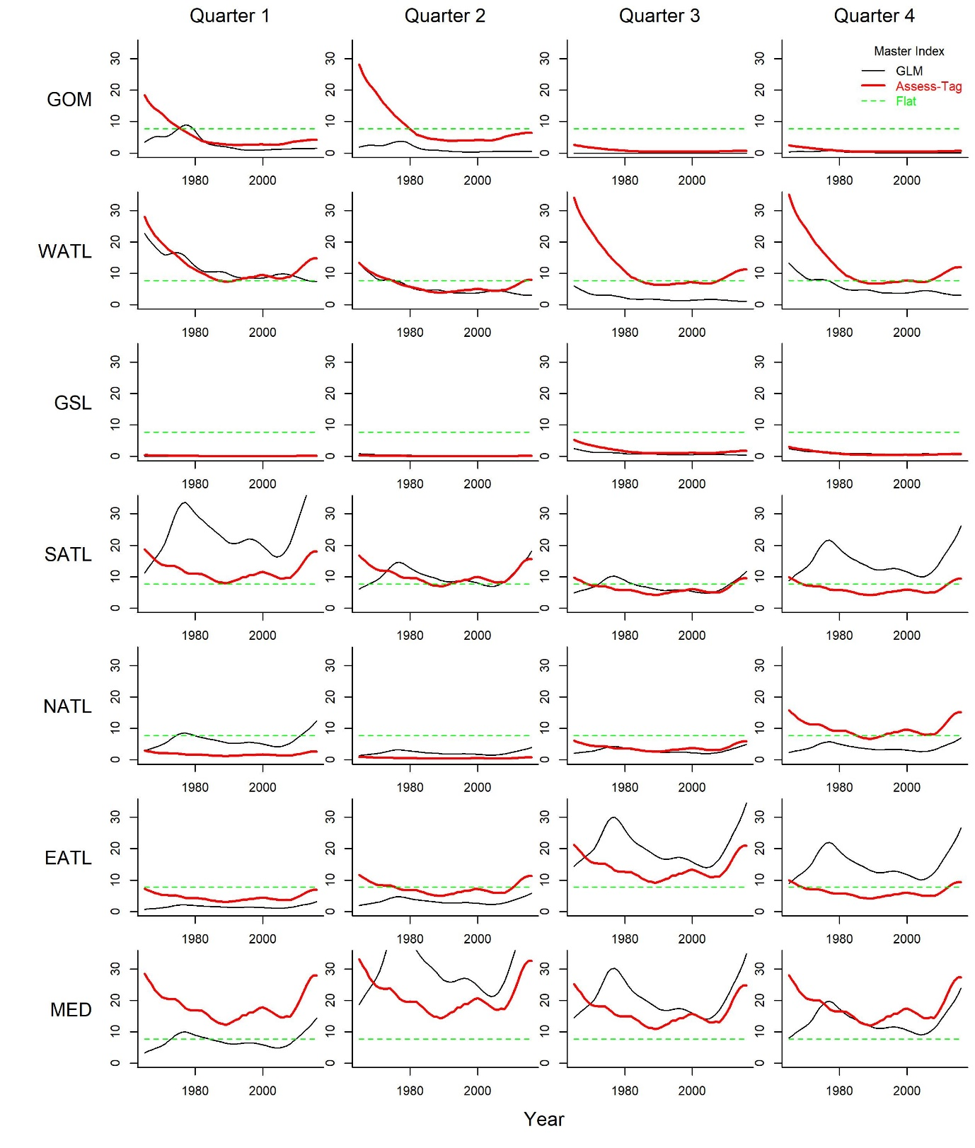

**Figure 1.** The seasonal and spatial distribution of relative abundance inferred by the three master indices derived by (1, ‘GLM’) GLM modelling of Task II catch per unit effort data and operating model relative abundance indices, (2, ‘Assess-Tag’) the most recent spawning stock biomass estimates of the stock synthesis assessments coupled with asymptotic seasonal distribution predicted by electronic tagging transitions and (3, ‘Flat’) a constant flat trend that is the same magnitude among all areas and seasons.

# Results

When using only the ‘GLM’ master index, the varying CV levels revealed that the master index was likely to have been highly influential in determining model predictions of both absolute biomass and stock mixing in previous version of the M3 model that relied on equation 3 (only seasonal-area deviations included). This is reflected by very large discrepancies in the absolute biomass of the eastern stock and mixing in Figure 2. At a CV value at 1 or 3, where the influence of the master index is greatly reduced, estimates were very similar.

This finding was further corroborated for spawning stock biomass (Figure 3), recruitment (Figure 4) and stock mixing (Figure 5) which show large differences among estimates of the quantities when CV = 0.1 that subsequently narrow and appear to converge for CVs of 1 and 3.

Mixing estimates were apparently much less stable than spawning stock biomass and recruitment, not converging as well with higher CV values. The only quantity not showing apparent convergence among master indices at the high CV levels was stock mixing of the West into the Eastern area (the bottom right panel of Figure 5) and shows some variability among estimates of very low percentage contribution of the western stock biomass to eastern area biomass.

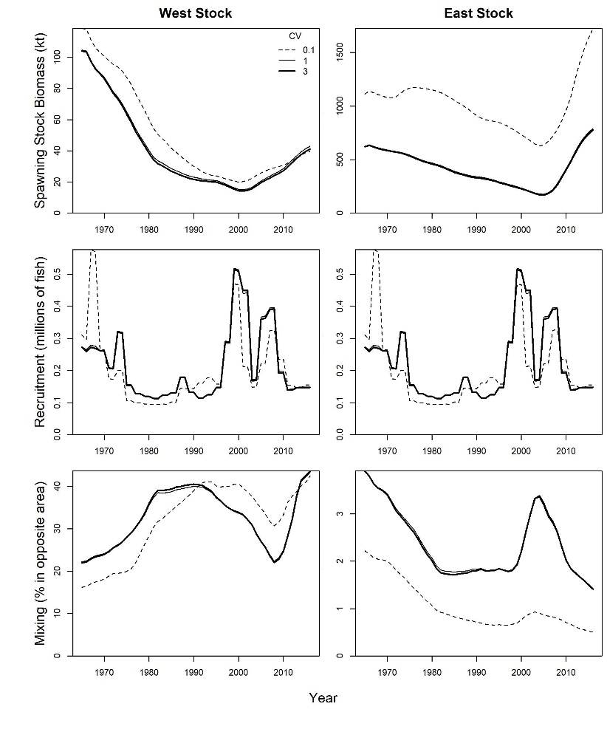

**Figure 2**. The impact of varying downweighting of the master index controlled by the CV in annual deviations (log normal penalty on annual recruitment, of Equation 3) for M3 model fits using the ‘GLM’ based master index.

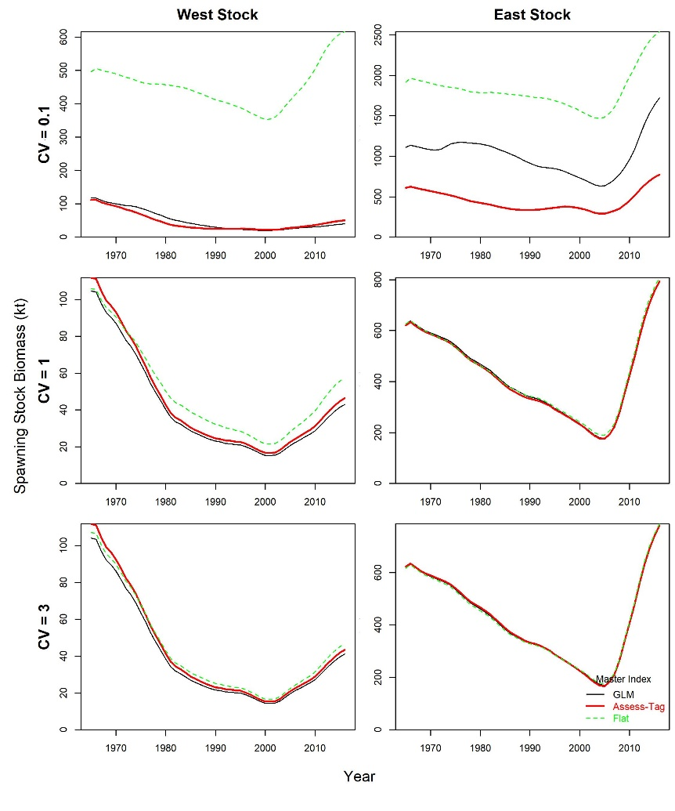

**Figure 3**. The sensitivity of maximum posterior density estimates of spawning stock biomass to varying master index and penalty on annual deviations, expressed as a CV.

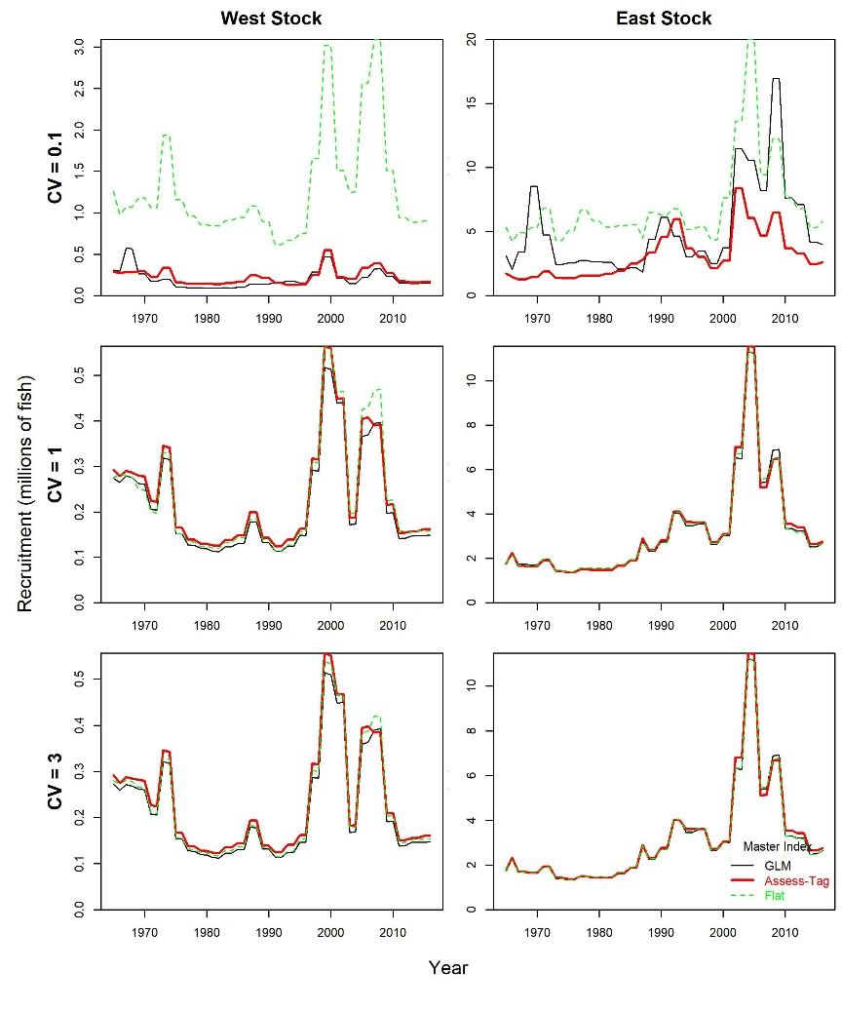

**Figure 4**. As Figure 3 but for recruitment estimates.

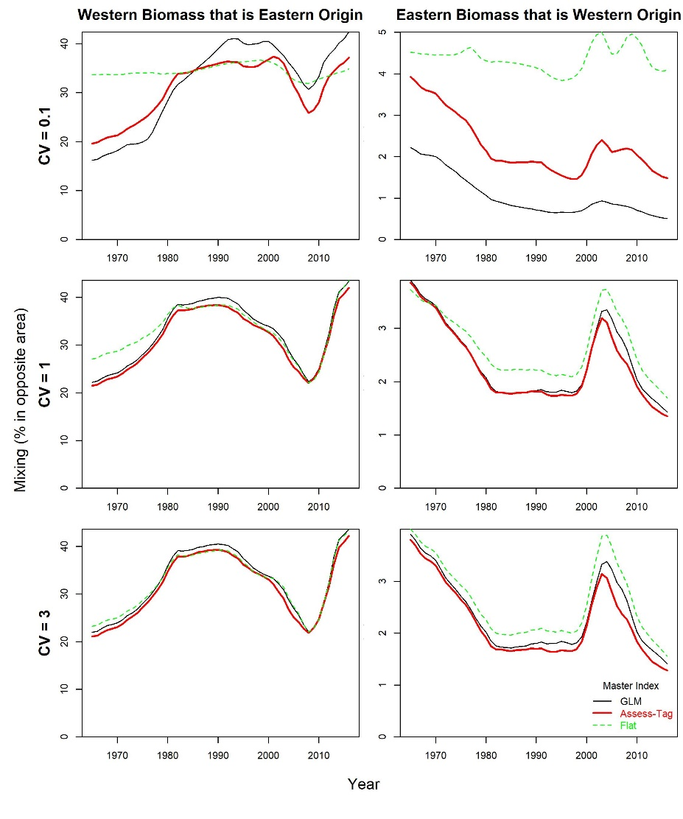

**Figure 5**. As Figure 3 but for estimates of stock mixing.

**Table 3**. Running times to maximum posterior density estimates (no hessian, no MCMC) of the current set of indices/CVs in absolute terms and also the increase over previous M3 model formulations (M3 versions 4 and earlier) that did not estimate the annual deviations (e.g. versions that used Equation 3 rather than Equation 5).



# Discussion

The results indicate that the master index probably did influence the estimates of previous versions of the M3 model that did not include the estimation of annual deviations (models based on Equation 3). The master index derived by GLM analysis is similar to the previous index and provided substantively different results in models with a lower CV and a greater prior weight on the trends of the master index.

Testing the new model that includes these deviations (based on Equation 5) with varying master indices and prior strengths (CVs) demonstrated that the posterior estimates can be considered largely invariant to the master index given a prior CV of 3 (in most cases a value over 1 appear sufficient). The choice of master index and CV had little impact on model running time. However, it is not clear yet whether the various master indices affect model stability and convergence across the full range of operating models.

Of the model estimates examined, stock mixing was estimated the least consistently well, particularly for the Western stock as a fraction of the eastern biomass. This may point to a general lack of information and local minima for parameters that determine these estimates.

It was interesting that ‘GLM’ master index approach and the ‘Assess-Tag’ approach often predicted qualitatively similar magnitudes in the seasonal-spatial distribution (the red and black lines Figure 1 are sometimes reasonably close in magnitude). It would be of further interest to see how close these priors are to M3 model estimates that use all of the spatial data. An extension to these approaches could combine all these data in addition to the stock of origin data to define an estimate of seasonal-spatial distribution that could be used in simplified stock mixing models (that are not reliant on the fitting of something as complex as M3).

An additional simplification to the model that may be worth investigating if model convergence becomes a problem and greater parsimony is required, could be to estimate a single parameter per season and area that controls a linear temporal trend (a linear mismatch between master index and model predicted abundance) that would reduce the additional 1428 parameters of Equation 5 to an additional 28 (7 areas, 4 seasons).

# Acknowledgements

I thank the ICCAT bluefin technical team for their continued feedback on operating model inputs, assumptions and estimates. This work was carried out under the provision of the ICCAT Atlantic Wide Research Programme for Bluefin Tuna (GBYP), funded by the European Union, several ICCAT CPCs, the ICCAT Secretariat and by other entities (see: http://www.iccat.int/GBYP/en/Budget.htm). The contents of this paper do not necessarily reflect the viewpoints of ICCAT or other funders and in no ways anticipate ICCAT future policy in this area.

# References

Anon. 2017. Report of the 2017 ICCAT bluefin stock assessment meeting. International Commission for the Conservation of Atlantic Tunas. Available online at: <https://www.iccat.int/Documents/SCRS/DetRep/> BFT_ASS_ENG.pdf [accessed October 2018]

Carruthers, T.R., Kimoto, A., Powers, J., Kell, L., Butterworth, D., Lauretta, M. and Kitakado, T. 2015a. Structure and estimation framework for Atlantic bluefin tuna operating models. ICCAT SCRS/2015/179.

Carruthers, T.R., Powers, J., Lauretta, M., Di Natale, A., Kell, L. 2015b. A summary of data to inform operating models in management strategy evaluation of Atlantic bluefin tuna. ICCAT SCRS/2015/180.

1. IOF, 2202 Main Mall, University of British Columbia, Vancouver, B.C., Canada, V6T 1Z4. [t.carruthers@oceans.ubc.ca](mailto:t.carruthers@oceans.ubc.ca)